Seeeduino Mega
http://www.seeedstudio.com/depot/seeeduino-mega-fully-assembled-p-438.html?cPath=27

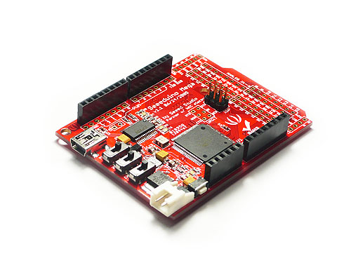

Seeeduino Mega is a microntrolller board based on ATmega1280, derived from Arduino Mega with changes in pursuit for small form factor, flexibility and functionality.It has 70 digital input/output pins (of which 14 can be used as PWM outputs), 16 analog inputs, 4 UARTs (hardware serial ports), a 16 MHz crystal oscillator, a USB connection, a power jack, an ICSP header, and a reset button. It contains everything needed to support the microcontroller; simply connect it to a computer with a USB cable or power it with a AC-to-DC adapter or battery to get started. Seeeduino Mega is compatible with most shields designed for the Arduino Duemilanove or Diecimila, also share accessories with Seeeduino family.

Difference vs. Arduino Mega:

1. Smaller (30% smaller) and flat form factor
2. All IO pin break out.
3. Move Reset button for easy access
4. 2.54mm alighment for proto boards compatiblity
5. 3.3V selectable for Port F and Port K (unstable performance on some boards, not recommended for current version.)
6. Auto/Manual reset selectable
7. Full featured Uart, Bitbang ready

Specification and Comparison

